



**DRIP IRRIGATION AND LEAKAGE DETECTION SYSTEM**

##### A MINOR PROJECT - III REPORT

###### ***Submitted by***

|  |  |
| --- | --- |
| **SANDHEEP S** | **927621BEC171** |
| **SANGEETH KUMAR R** | **927621BEC173** |
| **SANTOSH KUMAR S** | **927621BEC182** |
| **SARAN S** | **927621BEC184** |

###### 

##### 

**BACHELOR OF ENGINEERING**

in

**DEPARTMENT OF ELECTRONICS AND COMMUNICATION ENGINEERING**

**M.KUMARASAMY COLLEGE OF ENGINEERING**

(Autonomous)

**KARUR – 639 113**

**NOVEMBER - 2023**

**M.KUMARASAMY COLLEGE OF ENGINEERING, KARUR**

**BONAFIDE CERTIFICATE**

Certifiedthatthis **18ECP105/106L - Minor Project III** report “DRIP IRRIGATION AND LEAKAGE DETECTION SYSTEM**”** is the bonafide workof “SANDHEEP S (927621BEC171), SANGEETH KUMAR R (927621BEC173), SANTOSH KUMAR S (927621BEC182), SARAN S (927621BEC184)**”** who carried out the project work under my supervision in the academic year 2023 – 2024 - ODD

**SIGNATURE SIGNATURE**

**Dr.A.KAVITHA B.E., M.E., Ph.D.,** ,

**HEAD OF THE DEPARTMENT, SUPERVISOR,**

Professor, Dr. V. MARISELVAM

Department of Electronics and Department of Electronics and

Communication Engineering, Communication Engineering,

M.Kumarasamy College of Engineering, M.Kumarasamy College of Engineering, Thalavapalayam, Thalavapalayam,

Karur-639113. Karur-639113.

This report has been submitted for the **18ECP105/106L – Minor Project-III** final review held at M. Kumarasamy College of Engineering, Karur on **14-10-2023**

**PROJECT COORDINATOR**

**INSTITUTION VISION AND MISSION**

**Vision**

To emerge as a leader among the top institutions in the field of technical education.

**Mission**

**M1:** Produce smart technocrats with empirical knowledge who can surmount the global challenges.

**M2:** Create a diverse, fully -engaged, learner -centric campus environment to provide quality education to the students.

**M3:** Maintain mutually beneficial partnerships with our alumni, industry and professional associations

**DEPARTMENT VISION, MISSION, PEO, PO AND PSO**

**Vision**

To empower the Electronics and Communication Engineering students with emerging technologies, professionalism, innovative research and social responsibility.

**Mission**

**M1:** Attain the academic excellence through innovative teaching learning process, research areas & laboratories and Consultancy projects.

**M2:** Inculcate the students in problem solving and lifelong learning ability.

**M3:** Provide entrepreneurial skills and leadership qualities.

**M4:** Render the technical knowledge and skills of faculty members.

**Program Educational Objectives**

**PEO1:** **Core Competence:** Graduates will have a successful career in academia or industry associated with Electronics and Communication Engineering

**PEO2:** **Professionalism:** Graduates will provide feasible solutions for the challenging problems through comprehensive research and innovation in the allied areas of Electronics and Communication Engineering.

**PEO3:** **Lifelong Learning:** Graduates will contribute to the social needs through lifelong learning, practicing professional ethics and leadership quality

**Program Outcomes**

**PO 1: Engineering knowledge:** Apply the knowledge of mathematics, science, engineering fundamentals, and an engineering specialization to the solution of complex engineering problems.

**PO 2: Problem analysis:** Identify, formulate, review research literature, and analyze complex engineering problems reaching substantiated conclusions using first principles of mathematics, natural sciences, and engineering sciences.

**PO 3: Design/development of solutions:** Design solutions for complex engineering problems and design system components or processes that meet the specified needs with appropriate consideration for the public health and safety, and the cultural, societal, and environmental considerations.

**PO 4: Conduct investigations of complex problems:** Use research-based knowledge and research methods including design of experiments, analysis and interpretation of data, and synthesis of the information to provide valid conclusions.

**PO 5: Modern tool usage:** Create, select, and apply appropriate techniques, resources, and modern engineering and IT tools including prediction and modeling to complex engineering activities with an understanding of the limitations.

**PO 6: The engineer and society:** Apply reasoning informed by the contextual knowledge to assess societal, health, safety, legal and cultural issues and the consequent responsibilities relevant to the professional engineering practice.

**PO 7: Environment and sustainability:** Understand the impact of the professional engineering solutions in societal and environmental contexts, and demonstrate the knowledge of, and need for sustainable development.

**PO 8: Ethics:** Apply ethical principles and commit to professional ethics and responsibilities and norms of the engineering practice.

**PO 9: Individual and team work:** Function effectively as an individual, and as a member or leader in diverse teams, and in multidisciplinary settings.

**PO 10: Communication:** Communicate effectively on complex engineering activities with the engineering community and with society at large, such as, being able to comprehend and write effective reports and design documentation, make effective presentations, and give and receive clear instructions.

**PO 11: Project management and finance:** Demonstrate knowledge and understanding of the engineering and management principles and apply these to one’s own work, as a member and leader in a team, to manage projects and in multidisciplinary environments.

**PO 12: Life-long learning:** Recognize the need for, and have the preparation and ability to engage in independent and life-long learning in the broadest context of technological change.

**Program Specific Outcomes**

**PSO1:** Applying knowledge in various areas, like Electronics, Communications, Signal processing, VLSI, Embedded systems etc., in the design and implementation of Engineering application.

**PSO2:** Able to solve complex problems in Electronics and Communication Engineering with analytical and managerial skills either independently or in team using latest hardware and software tools to fulfil the industrial expectations.

|  |  |
| --- | --- |
| **Abstract** | **Matching with POs, PSOs** |
| Arduino UNO, 5V Relay, Moisture Sensor, Submersible Motor, Battery, Ultrasonic sensor | PO1, PO3, PO5, PSO1, PSO2 |

**ACKNOWLEDGEMENT**

Our sincere thanks to Thiru.M.Kumarasamy, Chairman and Dr.K.Ramakrishnan, Secretary of M.Kumarasamy College of Engineering for providing extraordinary infrastructure, which helped us to complete this project in time.

It is a great privilege for us to express our gratitude to Dr.B.S.Murugan., B.Tech., M.Tech., Ph.D., Principal for providing us right ambiance to carry out this project work.

We would like to thank Dr.A.Kavitha, Professor and Head, Department of Electronics and Communication Engineering for his unwavering moral support and constant encouragement towards the completion of this project work.

We offer our wholehearted thanks to our Project Supervisor, Mr.V.MARISELVAM, Degree, Job Title, Department of Electronics and Communication Engineering for his precious guidance, tremendous supervision, kind cooperation, valuable suggestions, and support rendered in making our project successful.

We would like to thank our Minor Project Co-ordinator, Dr.K.Karthikeyan, B.E., M.Tech., Ph.D., Associate Professor, Department of Electronics and Communication Engineering for his kind cooperation and culminating in the successful completion of this project work. We are glad to thank all the Faculty Members of the Department of Electronics and Communication Engineering for extending a warm helping hand and valuable suggestions throughout the project. Words are boundless to thank our Parents and Friends for their motivation to complete this project successfully.

**ABSTRACT**

Drip irrigation, also known as trickle irrigation, delivers water to plant roots at low rates (2–20 liters per hour) through small plastic pipes. This precise and water-efficient method conserves water, enhances plant health, controls weeds, and improves nutrient delivery. The proposed system fixes the L-shaped pipe at the end of the pipeline, and the water sensor is placed at the top of the L-shaped pipe based on the pressure of the water that is pumped by the motor. When the water level is raised to the top of the lid where the sensor is placed, the sensor detects the water, and there is no leakage. If any leakage occurs and the water level is decreased, then the sensor will not detect the water, and it will indicate the message by using a buzzer, and the motor will turn off.

KEY WORDS: Arduino UNO, 5V Relay, Moisture Sensor, Submersible Motor,

Battery, Ultrasonic sensor.

**TABLE OF CONTENTS**

|  |  |  |
| --- | --- | --- |
| **CHAPTER No.** | **CONTENTS** | **PAGE No.** |
|  | **Institution Vision and Mission** | iii |
|  | **Department Vision and Mission** | iii |
|  | **Department PEOs, POs and PSOs** | iv |
|  | **Abstract** | viii |
|  | **List of Tables** | xi |
|  | **List of Figures** | xii |
|  | **List of Abbreviations** | xiii |
| **1** | **INTRODUCTION** | 1 |
| **2** | **LITERATURE SURVEY** | 3 |
| **3** | **EXISTING SYSTEM`** | 5 |
| **4** | **PROPOSED SYSTEM** | 6 |
| **5** | **CIRCUIT DIAGRAM** | 7 |
| **6** | **COMPONENTS REQUIRED** | 8 |
| **7** | **RESULT AND DISCUSSION** | 19 |
| **8** | **CONCLUSION AND FUTUTE WORK** | 21 |
|  | **APPENDICES** | . |
|  | **REFERENCES** |  |

**LIST OF FIGURES**

|  |  |  |
| --- | --- | --- |
| **FIGURE No.** | **TITLE** | **PAGE No.** |
| 6.1.1 | Arduino UNO Board | 10 |
| 6.1.2 | 5V Relay Module | 11 |
| 6.1.3 | Moisture Sensor | 12 |
| 6.1.4 | Submersible motor pump | 13 |
| 6.1.5 | Battery | 14 |
| 6.1.6 | Ultrasonic Sensor | 15 |
| 6.1.7 | Jumper Cables | 16 |
| 6.2.1 | Arduino IDE | 18 |
| 7.1 | Result | 20 |
|  |  |  |
|  |  |  |
|  |  |  |
|  |  |  |
|  |  |  |
|  |  |  |

**LIST OF ABBREVIATIONS**

|  |  |  |
| --- | --- | --- |
| **ACRONYM** |  | **ABBREVIATION** |
| IDE | - | Integrated Development Environment |
| I/O | - | Input/Output |
| ICSP | - | In Circuit Serial Programming |
| LED | - | Light Emitting Diode |
| USB | - | Universal Serial Bus |
| AREF | - | Analog Reference |
| HW | - | High wattage |
| IOT |  | Internet of Things |
|  |  |  |
|  |  |  |
|  |  |  |

CHAPTER 1  
INTRODUCTION

Drip irrigation, a highly efficient and precise method of providing water to plants, offers numerous advantages in conserving water, promoting healthy plant growth, and minimizing the risk of diseases caused by overwatering. This irrigation technique involves delivering water directly to the base of each plant through a network of tubes, pipes, valves, and emitters, which ensures that the moisture is applied exactly where it's needed. To further enhance the precision and automation of drip irrigation, many individuals, farmers, and gardeners have turned to Arduino, an open-source electronics platform renowned for its versatility and cost-effectiveness. Arduino microcontrollers can be seamlessly integrated into drip irrigation systems, offering a range of benefits for those seeking to create a smart and efficient watering solution.

With Arduino, you can automate the irrigation process and implement various advanced features, such as scheduling, soil moisture sensing, weather-based adjustments, and remote monitoring. This combination of drip irrigation and Arduino technology is particularly appealing in today's context, where water conservation and sustainable agriculture practices are crucial. To set up a drip irrigation system using Arduino, several key components are required. These include an Arduino board to serve as the central control unit, soil moisture sensors for monitoring the moisture content of the soil, relays or solenoid valves to regulate the flow of water, a water pump to transport water from a source to the irrigation system, and the physical components of the drip irrigation system, such as tubing and emitters. Additionally, a power supply is necessary to provide the required electrical energy for the Arduino and other components to operate effectively.

The fundamental steps involved in creating an Arduino-based drip irrigation system are as follows. Soil moisture sensors are strategically placed in the root zone of the plants to regularly measure the soil's moisture level. These sensors play a crucial role in determining when and how much water is required. Custom code is written for the Arduino board, which enables it to read data from the soil moisture sensors and make decisions based on the moisture levels. When the soil moisture falls below a predetermined threshold, the Arduino triggers the water pump or solenoid valves to initiate the drip irrigation process. The Arduino assumes control over the water pump or solenoid valves, ensuring water is distributed to the plants at the right time and in the correct quantity. A scheduling system is implemented in the code to determine when and how often the system should irrigate. This can be based on factors such as the time of day or data from weather sensors, ensuring that the plants receive the appropriate care even when conditions change. For added convenience, the system can be enhanced with remote monitoring and control capabilities. This could involve creating a smartphone app or web interface that enables users to adjust settings, check system status, and make real-time decisions from anywhere with an internet connection. Regular maintenance is crucial to ensure the system's continued operation. This includes tasks such as cleaning emitters, verifying the correct functioning of sensors, and making any necessary adjustments to the irrigation schedule. By incorporating Arduino into a drip irrigation system, users can enjoy the benefits of automated, precise, and eco-friendly plant watering. The system conserves water, optimizes plant health, and offers the flexibility to adapt to changing environmental conditions. Whether for agricultural purposes, landscaping, or home gardening, an Arduino-based drip irrigation system is a sustainable and efficient solution that aligns with modern water conservation practices and the evolving needs of today's growers and gardeners.

CHAPTER 2  
LITERATURE SURVEY

After the deep research in the agricultural field, researchers found that the income of agriculture goes on decreasing day by day. Use of advanced technology within the field of agriculture plays very important role in increasing the agricultural production moreover as in reducing the additional human power efforts, water demand and fertilizer demand. A few of the researchers tried for betterment of farmers and provides the systems that use technologies that are useful for increasing the agricultural yield. Some of such research carried out in the field of agriculture are summarized below.

In [1], author said, in present drip irrigation system water is provided to root zone of plants drop by drop. It saves huge amount of water. The objective of the system is to a) Save valuable water resources b) Handles the system manually and automatically c) Detects the water level d) Builds such system which can improve crop productivity e) Learns choice way of irrigation based on different parameter. Present irrigation system Surface irrigation is also referred as flood irrigation. It states that the water distribution is uncontrolled and because it is inherently inefficient as well as not reliable. The disadvantage of fuzzy logic is that it gives same importance to all factors that are to be combined.

In [2], author said, smart drip irrigation system proves to be a helpful system because it automates and regulates the watering without any manual efforts. Sending the emails to the system can be automated but manual sending of the emails has control over the system regarding whether to run the system depending upon the weather conditions. In this system, solenoid valves and relay board are used. It can be controlled remotely which opens the opportunities to control the flow of water as well as the electrical flow. The limitation of this design model is that the failure of any particular part is not informed and must be tested manually.

In [3], author said, the benefits of using wireless sensors are having the reduced wiring and piping prices. Wireless system is easy for installation and maintenance in massive areas.

In [4], author said, digital camera is interfaced to Raspberry Pi via Wi- Fi module. Here the raspberry Pi takes pictures wirelessly using Mobile camera. Then image processing will be done by Raspberry Pi to identify soil colour samples. According to soil samples the Pi will transmit the information to user on the android app regarding the soil and seeds / crops which can be used on this kind of soil.

In [5], author said, the developed system is simple and price effective than most alternate systems present in the market. It measures totally different environmental conditions. It includes measurement of atmospheric temperature and soil temperature etc. Data transmission is finished by wireless module for communication purpose. Therefore, it can be used in open fields as well as within greenhouse. The range of wireless module is up to 25m with / without different obstacles like trees, wall, magnet, cupboard, benches, etc. Sensors can be placed anywhere in the field. If there is need of relocation, then it can be done simply. System is also tested for different temperatures, and it’s found that all the sensors work with minimum deviation in output. The use of drip irrigation, water is provided directly to the roots of the crop. So, wastage of water is decreased, and water resources are optimized to obtain higher quality of crops.

CHAPTER 3

EXISTING SYSTEM

Drip irrigation techniques currently in use a system of pipes, emitters, and tubing to supply water directly to plant roots. To provide effective and targeted irrigation, water is often dispensed in controlled drips or drops, primarily in agricultural and landscape applications.

Soil moisture sensors are used in automatic drip irrigation systems powered by Arduino to gauge the moisture content of the soil. These sensors send information to an Arduino controller, which decodes it and turns on solenoid valves to regulate the flow of water. Based on predetermined moisture levels, an Arduino software modifies the watering schedule. This method, which is Arduino-based, provides an economical and programmable way to automate and optimize plant irrigation while preserving water supplies.

CHAPTER 4

PROPOSED SYSTEM

The proposed system fixes the L-shaped pipe at the end of the pipeline, and the water sensor is placed at the top of the L-shaped pipe based on the pressure of the water that is pumped by the motor. When the water level is raised to the top of the lid where the sensor is placed, the sensor detects the water, and there is no leakage. If any leakage occurs and the water level is decreased, then the sensor will not detect the water, and it will indicate the message by using a buzzer, and the motor will turn off.

CHAPTER 5

5.1 CIRCUIT DIAGRAM

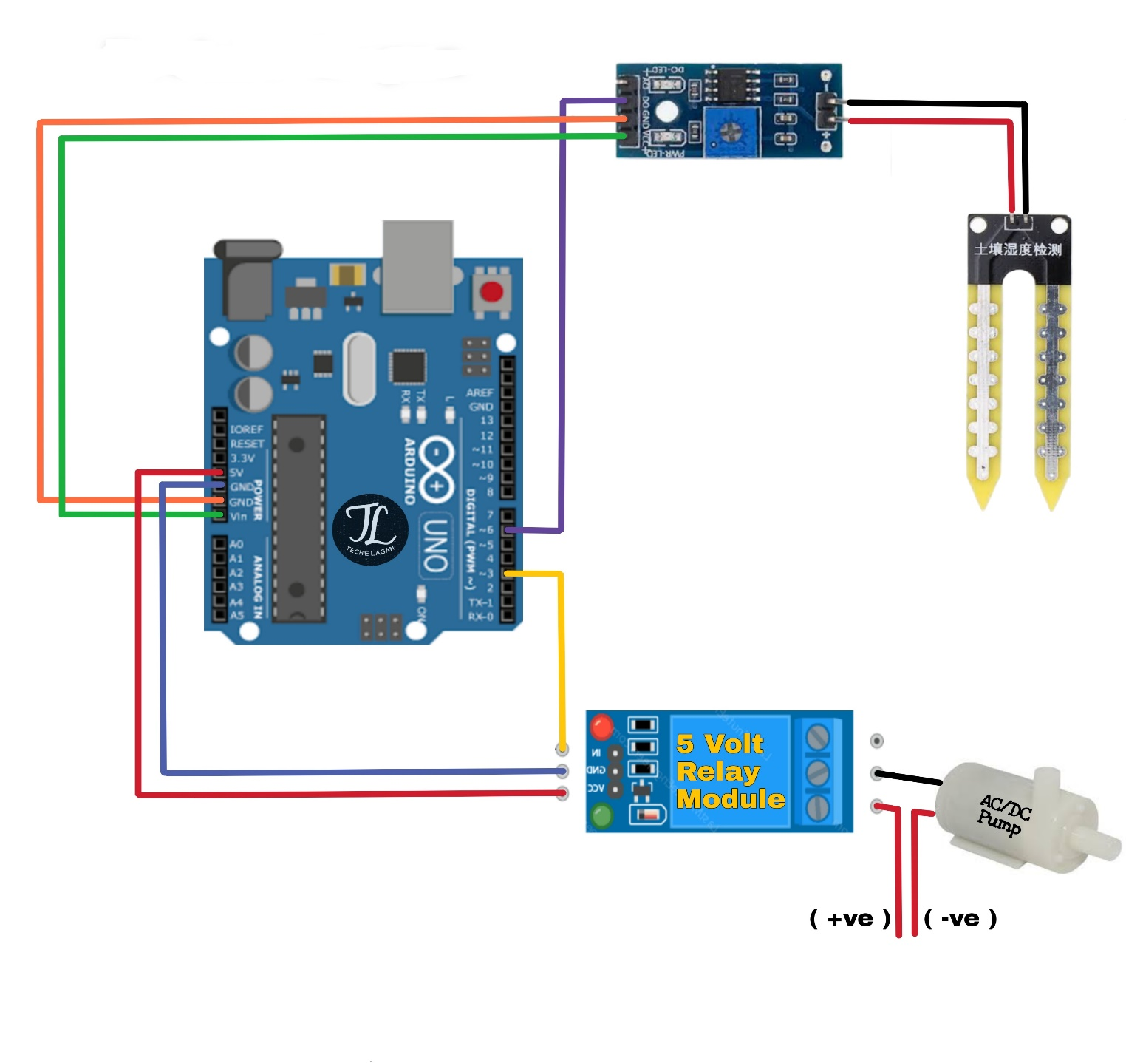

Fig.no: 5.1 Circuit diagram

CHAPTER 6

6.1 COMPONENTS REQUIRED

## 6.1.1 Arduino UNO Board

## 6.1.2 5V Relay Module

## 6.1.3 Moisture Sensor

## 6.1.4 Submersible motor pump

## 6.1.5 Battery

## 6.1.6 Ultrasonic sensor

## 6.1.7 Jumper cables

6.2 SOFTWARE REQUIRED

## 6.2.1 Arduino IDE

6.1 COMPONENTS REQUIRED

## 6.1.1 Arduino UNO Board

Arduino is a tool for making computers that can sense and control more of the physical world than your desktop computer. It's an open-source physical computing platform based on a simple microcontroller board, and a development environment for writing software for the board. Arduino can be used to develop interactive objects, taking inputs from a variety of switches or sensors, and controlling a variety of lights, motors, and other physical outputs. Arduino projects can be stand-alone, or they can communicate with software running on your computer (e.g., Flash, Processing.) The boards can be assembled by hand or purchased preassembled; the open-source IDE can be downloaded for free. The Arduino Uno is a microcontroller board based on the ATmega328. It has 14 digital I/O pins (of which 6 can be used as PW outputs), 6 analog inputs, a 16 MHz ceramic resonator, a USB connection, a power jack, an ICSP header, and a reset button. It contains everything needed to support the microcontroller; simply connect it to a computer with a USB cable or power it with an AC-to-DC adapter or battery to get started.

The Uno differed from all preceding boards by featuring the ATmega328P microcontroller and an ATmega16U2 (Atmega8U2 up to version R2) programmed as a USB-to-serial converter. Each of the 14 digital pins and 6 analog pins on the Uno can be used as an input or output, under software control (using pin Mode, digital Write, and digital Read functions). They operate at 5 volts. Each pin can provide or receive 20 mA as the recommended operating condition and has an internal pull-up resistor (disconnected by default) of 20-50K ohm. A maximum of 40mA must not be exceeded on any I/O pin to avoid permanent damage to the microcontroller. The Uno has 6 analog inputs, labeled A0 through A5; each provides 10 bits of resolution. By default, they measure from ground to 5 volts, though it is possible to change the upper end of the range using the AREF pin and the analog Reference function. Rather than requiring a physical press of the reset button before an upload. The RX and TX LEDs on the board will flash when data is being transmitted via the USB-to-serial chip and USB connection to the computer.

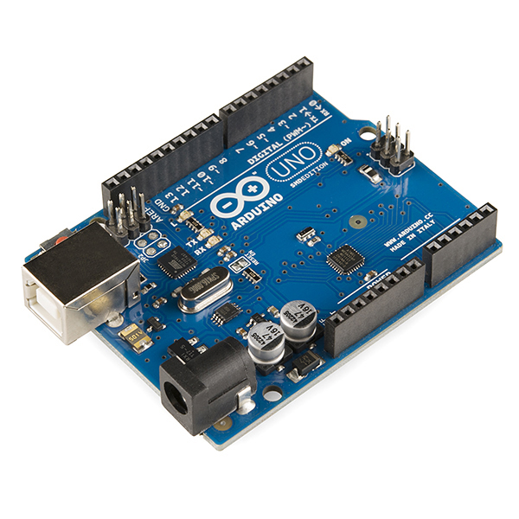

Fig.no: 6.1.1 Arduino UNO Board

## 6.1.2 5V Relay Module

A 5V relay module is an essential component in the realm of electronics and automation. It serves as an interface between low-voltage control circuits, often operating at 5 volts, and high-voltage devices or loads. The core of this module is a relay, an electromechanical switch capable of handling higher voltage and current. By applying a 5V signal to the control input, typically connected to a microcontroller or other digital source, the relay is activated, effectively switching its internal contacts. These contacts then allow or interrupt the flow of electricity through the output terminals, making it possible to control various high-voltage devices such as lights, motors, or appliances. Many 5V relay modules incorporate status indicators, usually LEDs, which provide a visual indication of the relay's state, aiding in monitoring and troubleshooting. Additionally, some modules offer opt isolation, isolating the low-voltage control circuit from the high-voltage side to enhance safety and protect sensitive components. 5V relay modules are widely used in a broad range of projects, from home automation to robotics, due to their capacity to enable the safe and convenient control of diverse electrical loads.

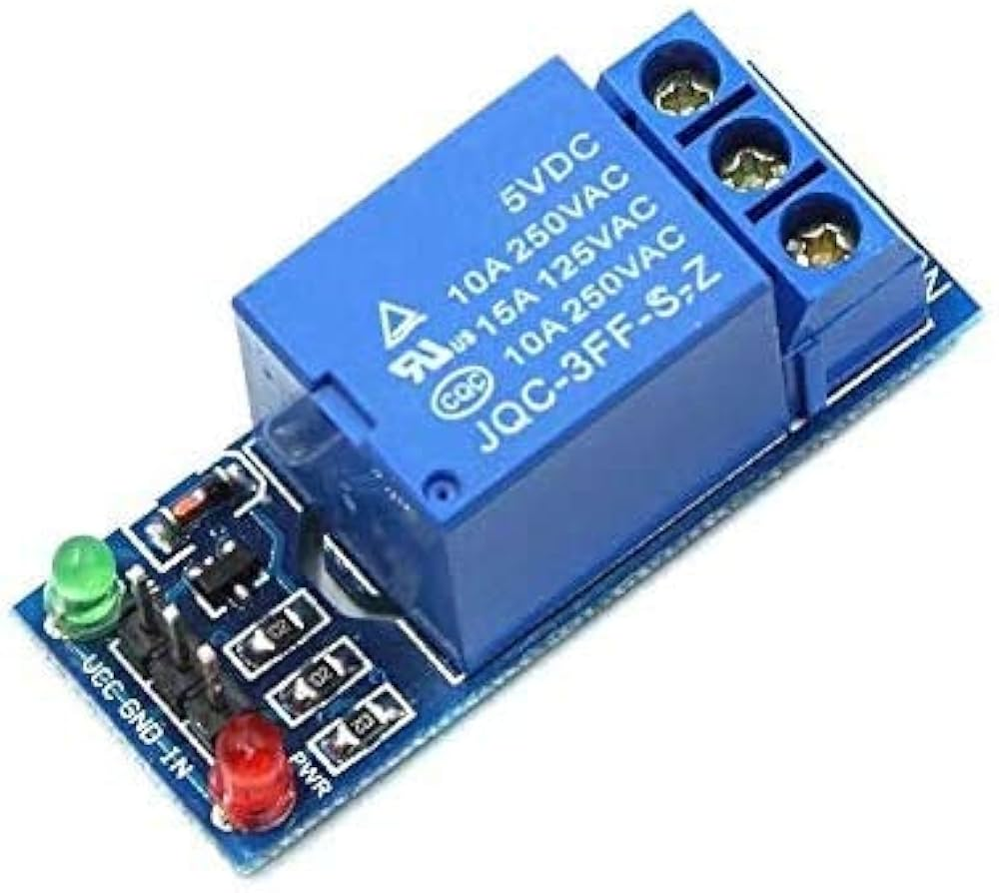

Fig.no: 6.1.2 5V Relay Module

## 6.1.3 Moisture Sensor

A moisture sensor, often referred to as a soil moisture sensor, is a fundamental component in agriculture, gardening, and environmental monitoring. Its primary function is to measure the moisture content in the soil, providing essential data to help users determine when and how much water should be applied to plants or crops. These sensors typically consist of two or more electrodes that are inserted into the soil. When the soil is dry, it has higher resistance, which decreases the electrical conductivity between the electrodes. Conversely, in moist soil, with higher water content, the conductivity increases. This change in conductivity is measured and converted into a moisture reading.

Moisture sensors are crucial for optimizing irrigation in both small-scale gardens and large agricultural fields. They help prevent overwatering, which can lead to water wastage and soil erosion, as well as underwatering, which can stress and harm plants. Many modern moisture sensors are designed to be integrated into automated irrigation systems, allowing for real-time monitoring and control. They play a pivotal role in sustainable water management, resource conservation, and maintaining healthy plant growth by ensuring that plants receive the right amount of water at the right time. Additionally, these sensors are also used in scientific research and environmental monitoring to study soil conditions and ecosystem health.

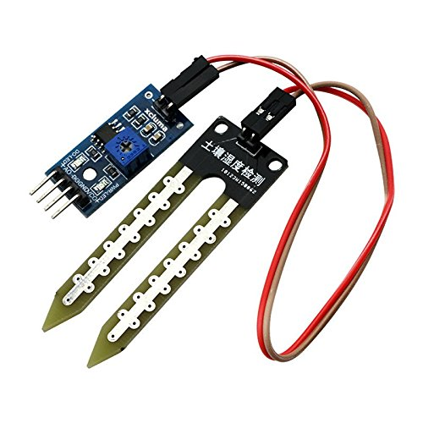

Fig.no: 6.1.3 Moisture Sensor

## 6.1.4 Submersible motor pump

A submersible motor pump, often simply called a submersible pump, is a highly efficient and specialized device designed for the purpose of moving liquids, such as water, from one location to another. What sets it apart from traditional pumps is its unique construction, as it is fully submerged in the fluid it is intended to move. These pumps are typically employed for various applications, including water supply in residential, commercial, and agricultural settings, drainage in construction and industrial processes, and groundwater control in wells.

The submersible motor pump is comprised of a hermetically sealed electric motor that is completely encapsulated in a waterproof housing. This motor is directly connected to an impeller, which is responsible for the actual pumping of the liquid. As the motor spins the impeller, it creates suction, drawing in the liquid, and then propels it upward to its intended destination. This submersion design not only enhances efficiency but also helps reduce noise and maintenance needs compared to surface pumps.

One of the primary advantages of submersible motor pumps is their ability to function underwater, allowing them to access water sources at various depths, including deep wells. Additionally, they eliminate the need for priming, as the water in which they are submerged provides the necessary pressure. These pumps are often selected for their reliability, energy efficiency, and extended lifespan. Whether in residential water supply, agricultural irrigation, or industrial applications, submersible motor pumps have proven to be a reliable and efficient choice for fluid transportation needs.

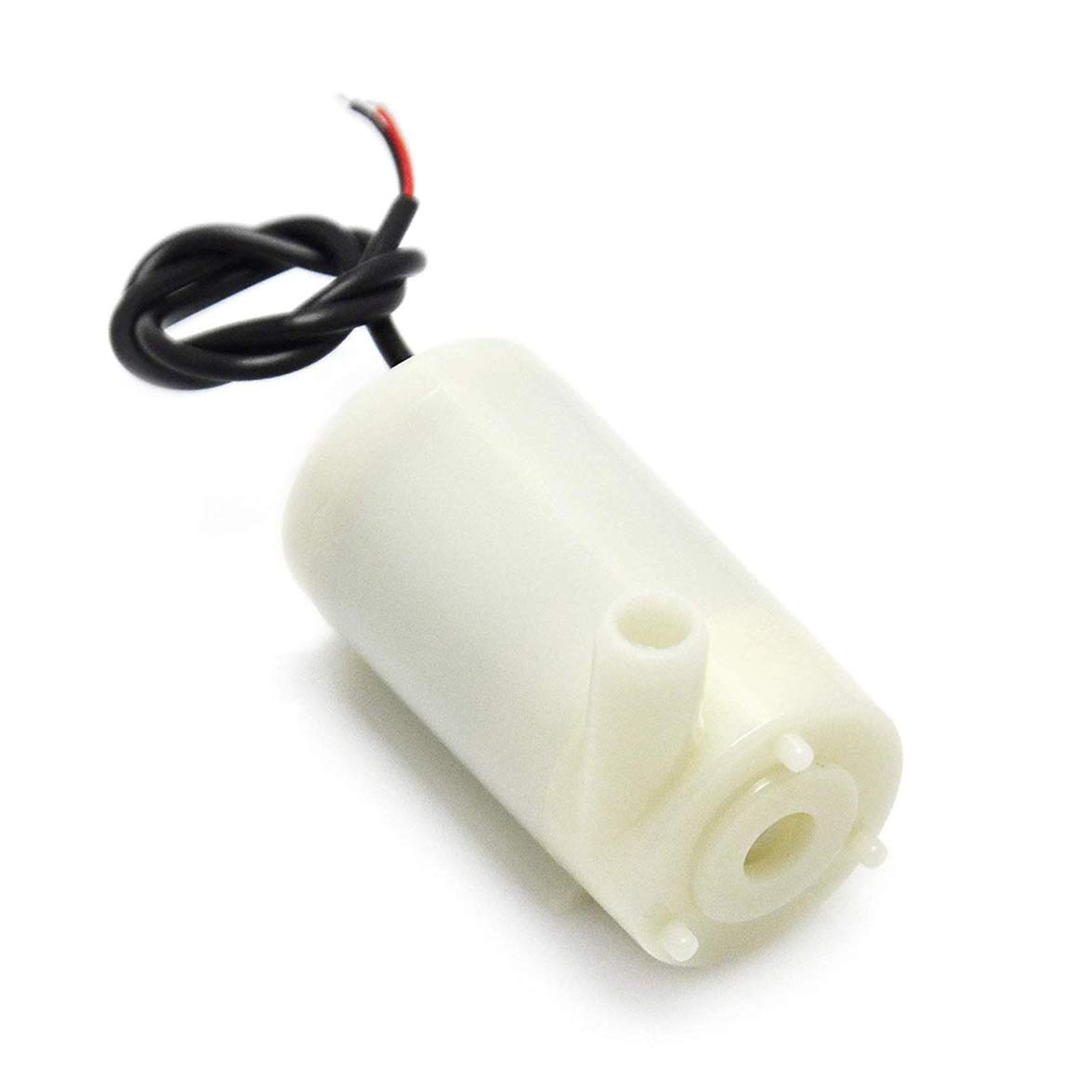

Fig.no: 6.1.4 Submersible motor pump

## 6.1.5 Battery

A high-wattage (HW) battery is a specialized rechargeable power source engineered to deliver substantial bursts of electrical energy in a short duration. These batteries find application in high-performance devices, such as electric vehicles, power tools, drones, and portable electronics, which require rapid and powerful energy output. High-wattage batteries achieve this by utilizing advanced materials and cell designs, ensuring they can discharge energy quickly without overheating or significant voltage drops. They strike a balance between energy density and power density, making them ideal for applications needing sudden surges of power. As electric transportation and energy-intensive tools gain prominence, high-wattage batteries play a pivotal role in facilitating the efficiency and portability of these technologies.

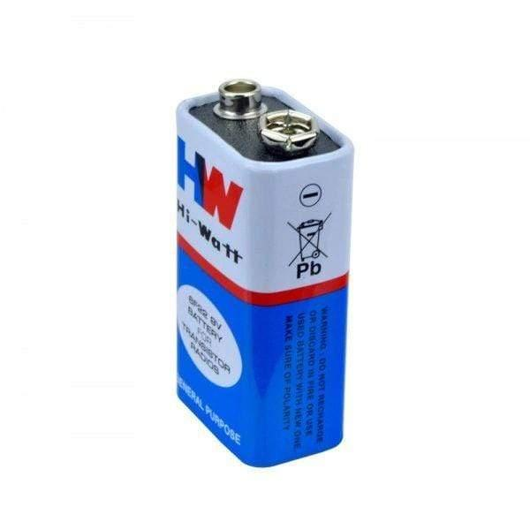

Fig.no: 6.1.5 Battery

## 6.1.6 Ultrasonic sensor

Ultrasonic sensors are highly versatile and sophisticated devices that have become integral to modern technology. They operate on a simple yet ingenious principle, using ultrasonic sound waves to measure distances and detect objects accurately. By emitting high-frequency sound pulses and then calculating the time it takes for these pulses to bounce off an object and return, these sensors provide precise distance data. What makes them exceptionally valuable is their adaptability and reliability. They are not influenced by object color, transparency, or surface texture, making them suitable for a wide range of applications. Their non-contact, non-invasive nature is advantageous, particularly in scenarios where physical contact is undesirable.

Ultrasonic sensors find application across numerous industries. In robotics, they are pivotal for navigation and obstacle avoidance, ensuring safe and efficient movement in dynamic environments. The automotive sector relies on ultrasonic sensors for parking assistance systems, enhancing driver safety and convenience. In industrial settings, these sensors are crucial for level sensing in tanks and silos, optimizing resource management and distribution. Beyond industrial and technical applications, ultrasonic sensors have become popular in interactive installations and hobbyist electronics, enabling projects that respond to human gestures, detect the presence of objects, and trigger actions based on proximity.

As technology continues to advance, the role of ultrasonic sensors in enhancing automation, safety, and efficiency across various industries is poised to expand. Their ability to deliver real-time, accurate distance data makes them an indispensable tool for modern technology and innovation, reshaping the way we interact with our environment and devices.

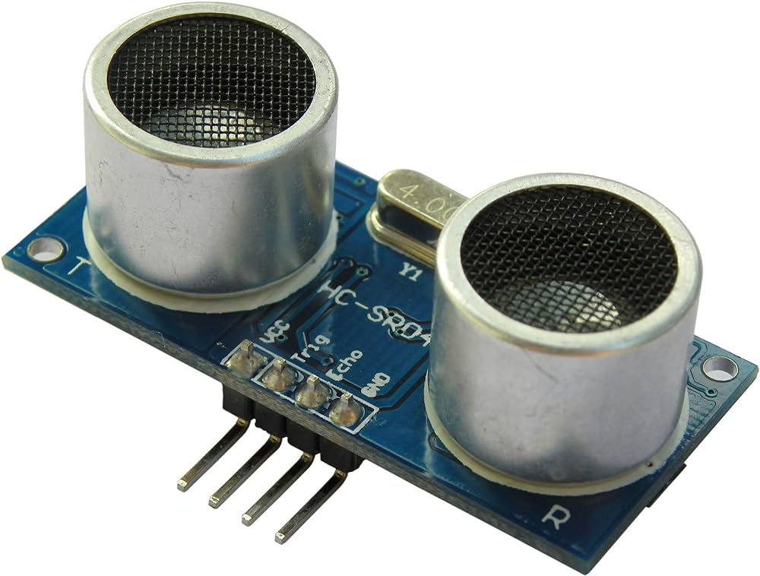

Fig.no: 6.1.6 Ultrasonic Sensor

## 6.1.7 Jumper cables

Jumper wires are used to connect components on your breadboard to the header pins on your Arduino. Wire up all of your circuits using them! Purchase jumper wires from Newark, SparkFun, Amazon, or Adafruit.Simply said, jumper wires are wires with connector pins at either end that can be used to connect two places without soldering. With breadboards and other prototype tools, jumper wires are frequently used to make it simple to change a circuit as required. as rubber or plastic to prevent electrical current from flowing outside the wire and causing a short circuit.

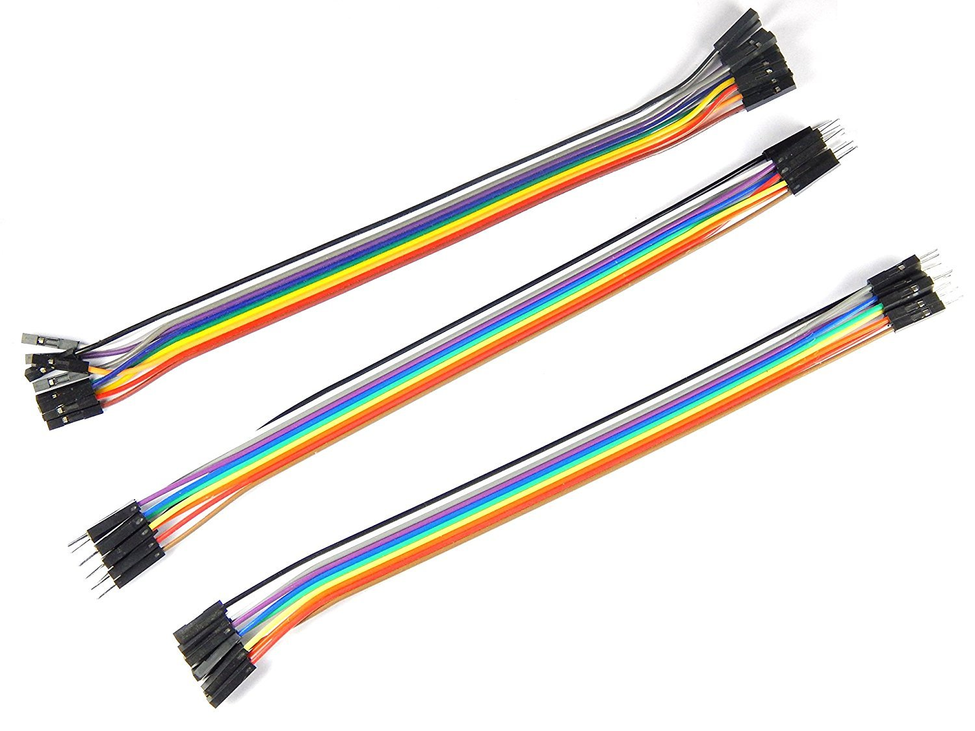

Fig.no: 6.1.7 Jumper Cables

6.2 SOFTWARE REQUIRED

## 6.2.1 Arduino IDE

The Arduino Integrated Development Environment, commonly known as Arduino IDE, is a cornerstone in the world of electronics and embedded systems. It serves as a versatile software platform that simplifies the process of programming and developing projects with Arduino microcontroller boards. What sets the Arduino IDE apart is its user-friendly approach, making it accessible to a wide range of individuals, from novices to experienced programmers. It employs a simplified programming language, based on Wiring, which is a modified version of C/C++, designed to be approachable for those with limited coding experience.

The IDE provides a comprehensive set of tools for writing, compiling, and uploading code to Arduino boards. Its code editor offers features like syntax highlighting, automatic code suggestion, and error checking, streamlining the coding process and making it less prone to errors. Additionally, the IDE simplifies the management of libraries and boards, allowing users to easily incorporate new functions and support for various microcontroller models.

Arduino IDE has been instrumental in promoting open-source hardware and the Maker Movement, facilitating innovation and creativity in the field of electronics. It has empowered countless individuals to transform their ideas into tangible projects, from simple LED blinking to complex robotics and automation systems. The open-source nature of Arduino encourages collaboration, enabling the community to contribute libraries and share code, further expanding the capabilities of the platform.

Overall, the Arduino IDE's intuitive and integrated environment has played a pivotal role in breaking down barriers to entry and empowering enthusiasts, educators, and professionals to explore the exciting world of electronics and embedded systems, fostering a culture of innovation and learning in the process.

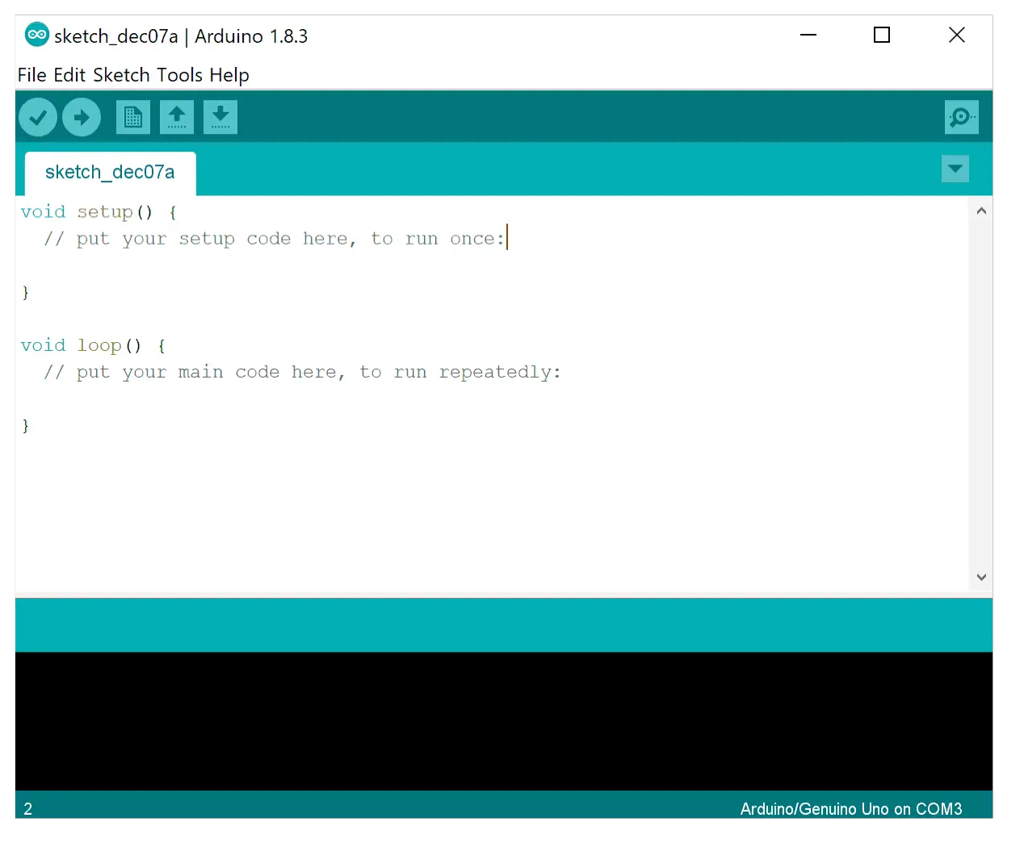

Fig.no: 6.2.1 Arduino IDE

CHAPTER 7

RESULT AND DISCUSSION

The application of Arduino technology to drip irrigation systems has yielded transformative results and implications. Arduino's precise control over water delivery and the ability to monitor soil moisture levels have significantly enhanced water efficiency in agricultural practices. This not only conserves a precious resource but also mitigates the risk of overwatering, which often leads to plant diseases and nutrient leaching. Consequently, these systems consistently promote healthier plant growth, increased crop yields, and improved crop quality, fostering sustainability and food security in the agriculture sector.

Resource conservation is another notable outcome of Arduino-based drip irrigation. Beyond water, the targeted delivery of water allows for the efficient use of fertilizers, reducing both the environmental impact and the cost of agricultural inputs. These findings underscore the potential of this technology to address the challenge of responsible resource management in agriculture.

However, it is essential to acknowledge the challenges that come with implementing Arduino-based systems, including initial complexity and maintenance requirements. The cost of components and the need for technical expertise may also be barriers to widespread adoption. Nevertheless, the results unequivocally demonstrate the advantages of Arduino-enhanced drip irrigation in terms of water efficiency, crop health, and resource conservation, making it a significant innovation for sustainable agriculture in an era of resource constraints and environmental awareness.

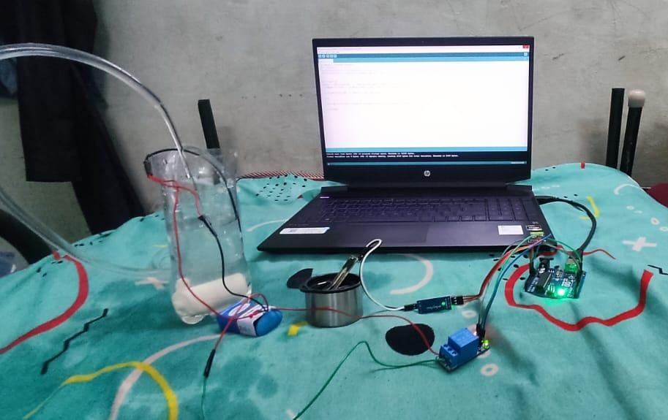

Fig.no: 7.1 Result

CHAPTER 8

CONCLUSION AND FUTUTE WORK

In conclusion, the integration of Arduino technology into drip irrigation systems represents a significant leap forward in sustainable agriculture and water resource management. The results are clear and compelling, with improved water efficiency, enhanced crop health, and resource conservation at the forefront of its advantages. The precision and automation of Arduino-based systems have the potential to address the global challenge of water scarcity while simultaneously boosting crop yields and minimizing environmental impacts.

Looking ahead, the future work in this field holds exciting prospects. Further research and development are needed to make these systems more accessible and cost-effective for a broader range of farmers and gardeners, especially in resource-constrained regions. Enhancements in data analytics, sensor technology, and connectivity can offer more sophisticated and adaptive irrigation systems that respond to real-time weather conditions, plant needs, and evolving environmental factors. Additionally, expanding the scope of remote monitoring and control through mobile applications and the Internet of Things (IoT) can empower users with greater insights and control over their irrigation setups. Overall, the future of drip irrigation using Arduino promises more sustainable and efficient water management practices, aligning with the evolving needs of agriculture in a world facing growing water challenges and environmental awareness.

REFERENCE

[1] Koushik Anand, Dr. C. Jayakumar, Mohana Muthu, Sridhar Amirneni, “Automatic Drip Irrigation System Using Fuzzy Logic And Mobile Technology”, IEEE International Conference on Technological Innovations in ICT for Agriculture and Rural Development, 2015.

[2] Nikhil Agrawal, Smita Singhal, “Smart Drip Irrigation System using Raspberry pi and Arduino”, International Conference on Computing, Communication and Automation, 2015.

[3] Aniket H. Hade, Dr. M.K. Sengupta, “Automatic control of drip irrigation system & monitoring of soil base wireless”, IOSR Journal of Agriculture and Veterinary Science, 2014.

[4] Suprabha Jadhav, Shailesh Hambarde, “Automated Irrigation System using Wireless Sensor Network and Raspberry Pi”, International Journal of Science and Research, 2014.

[5] Nilesh R. Patel, Swarup S. Mathurkar, “Microcontroller Based Drip Irrigation System Using Smart Sensor”, Annual IEEE India Conference, 2013.

[6] A. N. Arvindan and D. Keerthika, “Experimental investigation of remote control via Android smart phone of arduino-based automated irrigation system using moisture sensor”, Proc. of 2016 3rd International Conference on Electrical Energy Systems (ICEES), Chennai, 17-19 March 2016, pp. 168-175. Doi: 10.1109/ICEES.2016.7510636

[7] C. Kumar Sahu and P. Behera, “A low-cost smart irrigation control system”, Proc. of 2015 2nd International Conference on Electronics and Communication Systems (ICECS), Coimbatore, 26-17 Feb. 2015, pp. 1146-1152. Doi: 10.1109/ECS.2015.7124763

[8] D. Baghyalakshmi, J. Ebenezer and S. A. V. Satyamurty, "WSN based temperature monitoring for High Performance Computing cluster”, Proc. of 2011 International Conference on Recent Trends in Information Technology (ICRTIT), Chennai, Tamil Nadu, 3-5 June 2011, pp. 1105-1110. Doi: 10.1109/ICRTIT.2011.5972379

[9] A. K. Tripathy, A. Vichare, R. R. Pereira, V. D. Pereira and J. A. Rodrigues, “Open-source hardware based automated gardening system using low-cost soil moisture sensor”, Proc. of 2015 International Conference on Technologies for Sustainable Development (ICTSD), Mumbai, 4-6 Feb. 2015, pp. 1-6. Doi: 10.1109/ICTSD.2015.7095915

[10] R. M. Aileni, “Mobile application for tracking data from humidity and temperature wearable sensors”, Proc. of 2015 7th International Conference on Electronics, Computers and Artificial Intelligence (ECAI), Bucharest, 25-27 June 2015, pp. Y-1-Y-4. Doi: 10.1109/ECAI.2015.7301167

